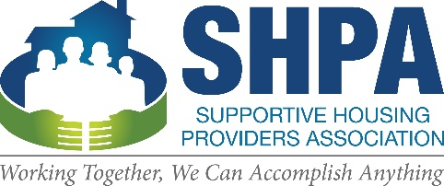

Residents Scholarship Program

Application Process
Through the Residents Scholarship Program, the Supportive Housing Providers Association values participation from the permanent supportive housing residents and consumers. We provide advocacy, leadership development, and educational opportunities for the memberships’ residents. Residents can come to the association meetings and conferences to learn about the specific campaigns SHPA is working on, get important updates within the state legislators, and network with other residents around the state. SHPA encourages residents’ participation in the meetings and understands the financial burden participation can have. The Resident Scholarship Program was created to cover the travel expenses for residents attending the meeting/conferences and other events geared toward resident participation. We thank you for your interest in attending these events. We ask residents to submit their applications at least 3 weeks before the meeting for processing. SHPA staff will review the applications, contact the potential recipient with any questions, and then notify the potential recipient one week before the event. If you have any questions regarding the application, the event, or any other questions, please contact Aaron Eldridge Sr., Northern Illinois Coordinator, at 217-321-2476 x1 or via email at a.eldridge@shpa-il.org.

Contact Information
Name:
Street Address:
City State, and ZIP Code:
Home Phone:
Work Phone:
E-Mail Address:
Organization/Agency:
Best way to contact you:

Application for the Resident Scholarship

Why are you interested in attending the Quarterly Meeting?

What does advocacy mean to you?

What leadership roles have you taken on in your organization or community?

Have you attended a SHPA Quarterly Meeting or event before? If so, which one(s)?

What do you hope to learn from this SHPA Quarterly meeting?

Person to Notify in Case of Emergency
Name
Street Address
City ST ZIP Code
Home Phone
Work Phone
E-Mail Address
Case Manager

SHPA Commitment
The Resident Scholarship is designated for supportive housing residents who want to participate in our meetings as well as attend other advocacy events hosted by the Supportive Housing Providers Association. Residents who receive financial support are asked to continue their advocacy work through participation in the Residents Committee. We ask that residents identify at least two ways s/he would like to participate.
__ Participate in monthly Resident Conference Calls |  | __ Invite a Resident to the next Conference Call
__ Make a submission to the SHPA Residents Newsletter |  | __Report your experience at the next Conference Call and/or at your supportive housing agency/organization

Accommodations
Please check all the accommodations you will need for the trip.
Train Fare | Transportation from train station to the hotel
___ 1 night hotel | Lunch at the Quarterly meeting
Lunch for travels | Other: ____________________________________
___ Gas

Our Policy
Please allow Supportive Housing Providers Association three weeks before the meeting/event for processing. If you have any questions regarding the application, the Meeting/Event, or any other questions, please contact Aaron Eldridge Sr., Northern Illinois Coordinator, at 217-321-2476 x1 or via email at a.eldridge@shpa-il.org. The policy of this organization to provide equal opportunities without regard to race, color, religion, national origin, gender, sexual preference, age, or disability.

Agreement and Signature
By submitting this application, I affirm that the facts set forth in it are true and complete. I understand that if I am accepted as a recipient I will respect the accommodations and commitments as well as appropriately all funds association with my acceptance of the funds.
Name (printed)
Signature
Date

