2020 Board of Directors

Angelia Smith,
President
Cornerstone Community Development Corporation

Lore Baker
Vice-President
Association for Individual Development (AID)

Kevin Nowlan,
Treasurer
Center for Prevention of Abuse

Johnna Lowe
Secretary
Corporation for Supportive Housing (CSH)

Felix Matlock
Immediate Past-President
Mercy Housing Lakefront

Lisa Kuklinski
Heartland Alliance

Fred Maclin
Amita Health: Housing + Health Alliance

Margarita Gonzalez
A Safe Haven

Millicent Ntiamoah
Catholic Charities of the Archdiocese of Chicago

Allison Gaitor
Resident Leader

Armando Smith
Housing Forward

Linda Thurmond
Brinshore Development

Nicole Warner
Cornerstone Services

January 1, 2020

Supportive Housing Provider;
As the Supportive Housing Providers Association enters a new year of advocacy for supportive housing, we would like to take this opportunity to tell you about the Supportive Housing Providers Association (SHPA) our accomplishments in 2019 and why you should consider becoming a member.

WHO WE ARE!
SHPA is a statewide (Illinois) coalition of non-profits providing supportive housing and services to extremely-low and low-income individuals and families experiencing homeless and/or chronic disabilities.
SHPA fulfills its mission to increase supportive housing and to build the capacity of providers through advocacy, quality improvement (by providing training & technical assistance), resident education and leadership development, seeking out innovative practices, and by being an information hub for our membership and those interested in supportive housing development. SHPA’s vision includes seeking an end to homelessness and the unnecessary institutionalization through supportive and community integration.
SHPA has worked to knit together its members including member organizations and member residents of supportive housing, into a strong state and federal advocacy voice for supportive housing resources and policies. We provide advocacy updates and connect supportive housing staff and residents to state and federal advocacy campaigns. We strive to build relationships with elected officials in order to develop supportive housing champions with the legislature. SHPA strongly believes in advocacy from those with lived experience of homelessness and/or persons with disabilities who reside in Supportive Housing. The authenticity of their personal story weighs more in the battle of ending homelessness and unnecessary institutionalization.

2019 ACCOMPLISHMENTS:
A lot has happened at SHPA over the past year! none more significant than our successful advocacy;
- Funding increase for Supportive Housing Services in the FY2020 State budget to $41.2 million from $32.7 million an increase of 26% and the largest increase since 2013.

- Collaboration with our advocacy partners on issues such as:
  - $ 4 million increase in Homeless Prevention Funding
  - $ 200 million capital funding for the development of affordable housing
  - Mental Health Legislation
  - Passage of the graduated tax referendum for the November 2020 ballot
  - Cook County Just Housing Initiative
- Capitol Hill Day in Washington DC
- 2019 Advocacy Day in Springfield
Other SHPA 2019 Activities:

- Resident & Fall Member Conference
- Regional Trainings: Supportive Housing Dimensions of Quality
  - Mount Vernon, Peoria, Chicago
- Resident Storytelling Workshops
  - Mount Vernon, Peoria, Rockford & Chicago
  - A Place to Call Home; Publication
- And so much more.

2020 PRIORITIES:

- Maintain & Increase funding for Supportive Housing Services
- Increase funding to address the impact of the Minimum Wage on Supportive Housing
- Passage of the referendum for the Graduated / Fair Income Tax
- Housing is Recovery Pilot Program
- Supportive Housing Development through the Capital Budget for Affordable Housing
- State Plan Amendment or other mechanism for the broad expansion and implementation of Medicaid reimbursement for pre-tenancy and tenancy supports.
- State supported Interagency Council on Ending Homelessness and Unnecessary Institutionalization

Come join us and be part of an association that is proud to be the voice of supportive housing providers across the State of Illinois and works every day alongside and on behalf of residents of supportive housing and those that are most vulnerable that need us to be their voice.

For your convenience we have attached our Membership Agreement Form. Fore more information you can visit our website at www.shpa-il.org or you may contact David Esposito, Executive Director at 217-321-2476 x2 or via e-mail at d.esposito@shpa-il.org.

We look forward to working with you in the year ahead.

Sincerely,

Angelia Smith David Esposito
Angela Smith David Esposito
Board President Executive Director

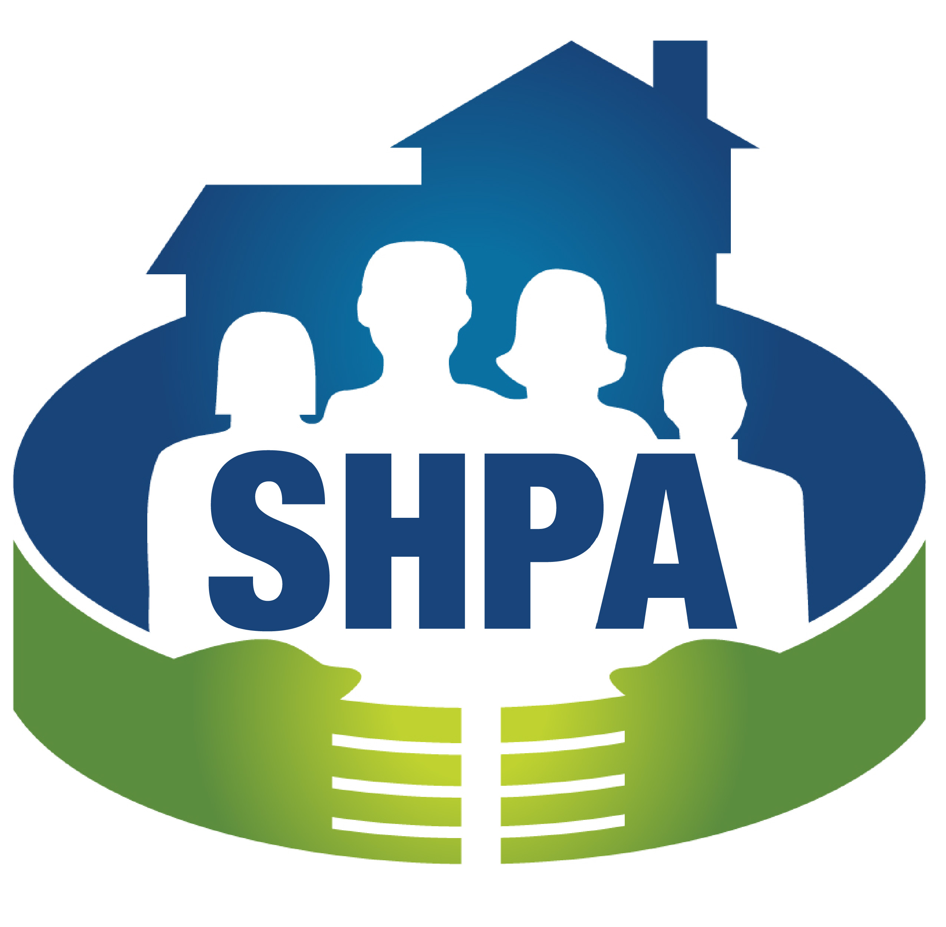 Membership Contact Form

Name of Organization:

Address:

Name of Executive Director/CEO:

Phone: Email:

Name of Accounting/Financial Contact:

Phone: Email:

Name of Housing Contact:

Phone: Email:

Name of Social Services Contact:

Phone: Email:

Additional Contacts: (name and e-mail)

___________________________________________ ____________________________________________

___________________________________________ ____________________________________________

Total Agency Budget $ ________________________________

Total Supportive Housing Budget $ _____________________________

Are you a Certified Medicaid Billing Agency? ☐ Yes ☐ No

Membership Agreement (page 1 of 2)
Please sign the membership agreement and send to the address listed below.

The Supportive Housing Providers Association exists to advocate for issues that will increase and strengthen the supply of supportive housing, to provide a forum for members to discuss their experiences, and to increase the effectiveness of its members through the dissemination of information.

I understand that if my organization is accepted as a member of the Supportive Housing Providers Association that membership carries certain privileges and responsibilities.

The privileges and benefits of membership include:

- Legislative advocates working regularly on behalf of SHPA members and periodic strategic advice for developing and nurturing relationships with legislators.
- Ability to vote on major legislative/policy issues and priorities which guides SHPA’s advocacy efforts.
- Timely knowledge for Call to Action or Action Alerts and necessary materials, such as letter templates or call scripts pertaining to important legislation that impacts supportive housing and residents.
- Forum for information sharing on the current financial and political environment for developing supportive housing.
- Benefits of networking with providers of supportive housing from across the state and sharing of best practices at semi-annual associations meetings and regional workshops at least 2x per year.
- Benefits of broader network of members and affiliates, such as Healthcare Systems, Landlords & Developers, Managed Care Organizations
- Free or discounted attendance at regional workshops that could include CEU credits for further staff development.
- Access to any studies or educational materials developed by or shared with SHPA for educating legislators and the public regarding supportive housing.
- Robust Resident Leadership Program to assist residents in their advocacy development and Scholarships to attend the Annual Resident Conference Annual and Spring Association meetings, and other local and national conferences as budget allows.
- Electronic Peer to Peer program to share ideas, discuss challenges, and information sharing as needed.

The responsibilities of membership include:

- Agreeing to maintain confidentiality and trust which will enable members to discuss their projects in an environment, which is not threatening to their organization’s viability.
- Agreeing to share honestly with other members your experience so that all members can learn from it to improve their projects.
- Agreeing to pay annual dues according to the sliding scale below for membership in the Supportive Housing Providers Association.
- Membership meeting attendance whenever possible.
- Participation in major SHPA advocacy campaigns through calls, letters, or visits to legislators.

Your organization’s dues are based on the size of your organizational budget as follows:

- Not-for-Profit Organizations with budgets:
  - $ 0 to $ 250,000 pay annual dues of $ 460
  - $ 250,001 to $ 500,000 pay annual dues of $ 805
  - $ 500,001 to $1 million pay annual dues of $ 1,725
  - Over $1 million pay annual dues of $ 2,300

- Not-for-Profit Organizations desiring to team, align, join in, ally or band together with the association $ 375 (limited membership benefits)
- Continua of Care pay annual dues of $ 100
- For Profit business or entity operating to make profit and/or has a scope outside of social services and interested in participating in SHPA activities; pay annual dues of $ 575 with additional sponsorship opportunities available. (limited membership benefits)

Failure to meet the responsibilities of membership can result in loss of membership in the organization and the forfeiture of all dues paid. Membership in SHPA does not constitute the automatic endorsement by SHPA of the applying organization’s activities. By signing my name to this document, I agree that if my organization is chosen for membership, we will abide by the responsibilities outlined above:

Signed: __________________________________ Date: ________________
CEO/Executive Director

Print: ________________________________
CEO/Executive Director

Please return completed membership agreement & membership fee to:

Supportive Housing Providers Association (SHPA)
6 Lawrence Square Springfield, IL. 62704
Attention: Mary Palmer Email: mpalmer@firminc.com

